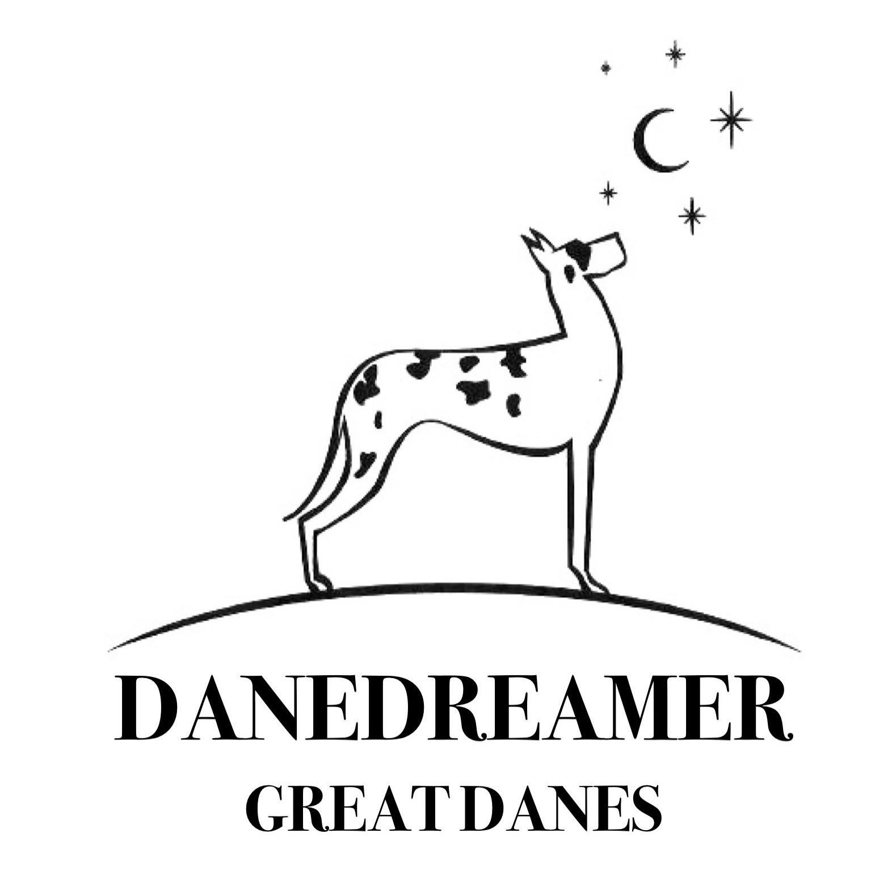
FEEDING GUIDE

ANKC DANEDREAMER GREAT DANES .
Mobile 0450955527
Email: kimmidolljanssen@gmail.com
Kimberley Janssen

Feeding guide

Enduro Complete (21% protein, 10% fat content)

Please stay away from chicken-based kibble, rather use kangaroo, lamb or beef is a much more stable protein for growing your Dane.

NEVER FEED KIBBLE OVER 26% PROTEIN

Kibble toppers: you can alternate between these options, variety is key

A handful of red meat mince, Kangaroo, Lamb or Beef Mince (I get my butcher to mince Ox tongue) with approximately 20% fat content.

An egg

Tuna in Springwater from coles or woollies

Tablespoon of Yoghurt (live Yoghurt from a supermarket, Jalna)

I tend to only use human grade chicken mince from coles or woollies, I haven’t found a pet food shop that has nice chicken.

Chicken Necks up to 3 in a meal I also get my butcher to order these 12kg $21-00)

Growing your pup correctly can be gauged by the reaction of the front legs.
If your pup is growing correctly, the front paws will always point forward as the pup is walking toward you, the feet should be cat like with well arched toes. Flat feet by the end of the day, means your pup has been doing too much and needs to sleep more.

Value Plus, Iron and mineral supplement 1 tab per 30 KG (order tablets from the pet shop or ring 02 9688 3220 and order direct available in 500’s) OR Zinc tablets (from a Health food shop if you cannot get the Value Plus)

Acidophilus capsules, Inner Health Plus, From the Health food shop they are kept in the fridge and you keep them in the fridge.

Vitamin C 250 mg (buffered from the chemist) Ester C is the best. 250 mg to start with increasing to 500mg at 12 weeks when they start teething,

ONLY change the dry food IF the following occurs

Pedigree Advance Adult If your pup starts to knuckle over on it’s front legs or if you notice the front legs shaking when the pup is in the sitting position.

If your pups feet start to go east West, turning outward when in the standing or walking position (Increase the meat content of their diet the feet will return to normal in a week)

Speak to me if any issues or concerns occur, happy to chat.

Your puppies legs and feet will tell you what to alternate in your diet.
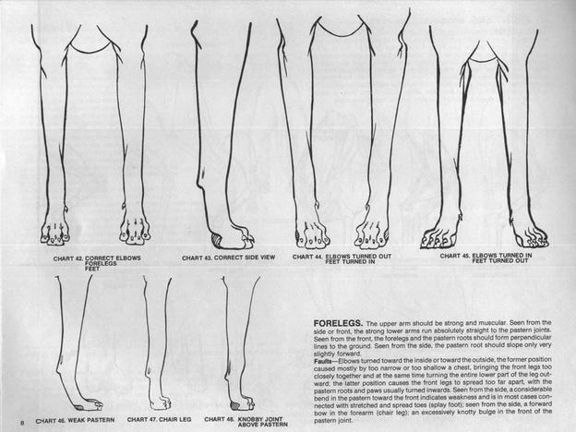

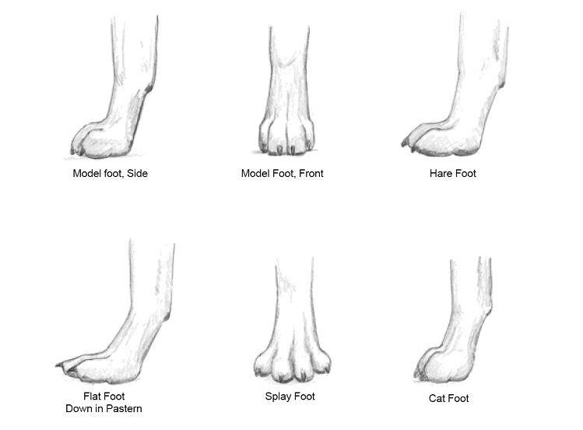

NEVER add calcium to your Great Dane’s diet (even if your vet tells you to do so) they draw natural calcium from the dry food and the bone content in the diet and Vitamin C helps them absorb it and metabolise it.

Value Plus or Zinc is very important to the Great Danes Diet, it assists in the correct growth and development the pups bone structure and it is essential for proper function of the pups glands, the dose is 1 tablet per 30 KG so you increase the dose as the pup grows.

Cold Weather can play havoc with ligaments in the front legs, so if it’s cold put a rug on your pup when they are out.

FEEDING GUIDE – this will vairy based on your puppies weight so add or subtract based on his/her weight and energy needs. There is no exact rule as puppies have different metabolisms

Breakfast
2-3 cups of Enduro complete dry food
½ cup warm water over the top
2 (golf ball size) raw mince balls, kangaroo, lamb or beef.
1 desert spoon of Yogurt (skip if poop is runny)

3 raw chicken necks (bash them a couple of times with a meat tenderiser to break them up a bit bone wise) give this after breakfast

NO LUNCH

Dinner

2-3 cups of Enduro complete dry food moistened with warm water until soft.
2 (golf ball size) raw mince balls
1 desert spoon of Yogurt
1/2 Value Plus or Zinc tablet
Vitamin C 250 mg
1 Inner Health Acidophilus Capsule

Please increase as needed

If your pup doesn’t eat the whole meal or seems bored with the food, you can add one teaspoon of Puppy Food (canned) OR one sardine from a tin or sprinkle a little Parmesan. Only do this if you need to.

Food should be increased every fortnight by a half a cup of kibble, at the same time increasing the meat by one quarter as well, the total of meat should always be a approx quarter of the meal.

Soak Kibble always as this helps to prevent bloat by them not swallowing extra air with dry kibble.

Always clean your dogs bowl before preparing his meal, a dirty bowl can breed bacteria which can also cause bloat.

BY 12 weeks of age a meal should be
2 ½ cups of soaked dry food
3 golf ball sized
2 desert spoons of yogurt .
breakfast and dinner the same. Tablet’s on the dinner feed. Increasing the Vitamin C to 500mg

At this age you can start them on raw brisket bones or lamb flaps, approximately 1 or 2 small bones after the chicken necks at breakfast, also if they are not that interested in eating kibble (dry food) for the breakfast then replace it with 5 to 6 chicken necks plus a small brisket bone or lamb flap.

Weigh your puppy weekly, do not let them grow faster than 2kg per week, if your pup grown more than this in a week, just cut back their food slightly, if he only puts on 1 kg for the first 4 weeks this is normal, increasing to 2 kg by 12 weeks.

Your pup should look well covered, not skinny and not sunken around the flank area, you need to be able to feel his ribs just under the skin without seeing them. Your pup will be a greedy gut’s when you first get him home, so don’t be fooled into giving him extra food.

NEVER leave food out, what they haven’t eaten in 15 min can be covered and placed in the fridge, he will soon learn. Also always feed at shoulder height adjusting height as he grows.

NEVER feed cooked bones of any type, always RAW bones in the morning the digestive juices (hydrochloric acid) are stronger in the morning and they are digested and absorbed better.

VEGETABLES can be added at 4 months as well as pasta and leftovers, avoiding onions, cabbage and any gas producing things (Bloat prevention)

ALWAYS have lots of fresh water available

Other advice

DO NOT take your pup out until he has had his second vaccination at 14 weeks of age.

After the 14 week vaccination, it is good to socialise your pup with puppy pre-school, Dane pups enjoy lots of interaction with people and other animals. If you cannot attend a puppy socialization class, then take your pup to shops even to a Primary school, when the children are due out.

Buy lots of toys from the local Salvation Army store, they are always cheap, have two lots of toys and swap them so they are not bored and be wary of toys they could swallow (imagine you are buying for a 2 year old child) plastic milk and coke bottles with a little rice in them and seal the top are enjoyed and watch out for stairs, always supervise, pups can always fall and hurt themselves.

DO NOT over exercise your pup, five minute walk’s for socializing is all that is needed in the first 6 months, because of the rapid growth up until 8 months they require more sleep with the need decreasing as the get older. Once fully grown, your Dane will be able to handle more exercise.

One of the most important thing with a Dane puppy is to avoid injury, running around uncontrollably, because with the rapid growth it is very difficult to heal injuries so it is better to prevent them, so avoid stairs, jumping off furniture getting bowled over by another dog or children trying to pick them up, jumping in and out of cars (it is like looking after a 2 year old child)

WORMING

Worm at 12 weeks with Canex or Drontal then every three months after that or if you are using one of those total monthly control treatments and are in a heartworm area be advised by your vet as they will know what is best for your area.

VACCINATION

You will be given a Vaccination Card which will outline your pups vaccinations up to date but you pup will require a booster at 14 weeks of age with CANIGEN C3 then again at 12 months

DO NOT let your vet use Protec Vaccination on your pup, only CANIGEN C3 DO NOT Vaccinate with C4 or C5 your puppies immune system will not be strong enough to handle it and it could cause serious problems, if your vet will not use Canvac find another vet, DO NOT get talked into anything else.
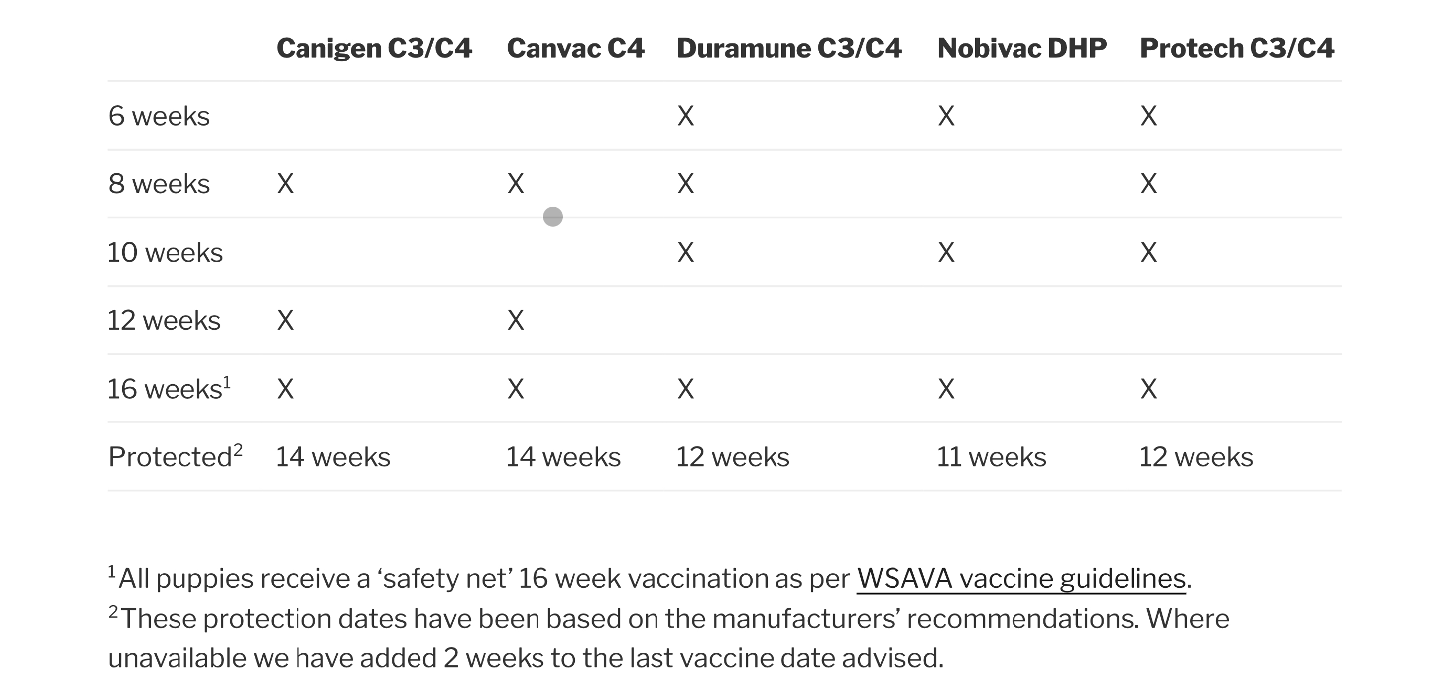

Your next vet appointments with instructions:

- 12 weeks old : CANIGEN C3 Vaccine - Please request vet do a Coccidiosis treatment with Baycox.
- 16 weeks old : CANIGEN C3 Vaccine + kennel cough vaccine UP THE NOSE + All wormer.

BEDDING Great Danes pups are big with big bones, they need plenty of soft bedding to cushion their joints from hard surfaces, they can end up with injuries to joints.

AVERIES AND CAGED BIRDS

Please keep your pup away from caged birds or chickens, pups can get diarrhoea and other diseases from birds, never let your pup have diarrhoea 2 days before taking them to the vet a course of Trizine will fix the problem up another reason not to leave food out it attracts wild birds.

Please if you have any queries regarding any of this information or about your pup…ring me…Jenni Casalaz 9787 3459 or 0407 309 456.

I will have the answers to your questions, please ring me first before ringing a vet as I can quite often save you a vet bill, most vets do not breed Great Danes!!!!!
If for any reason you can no longer keep the pup or adult Great Dane in the manner you have promised me you will…they are to be returned to me not offered to shelters or pounds, as I have worked had with Dane rescue I have many people on my books wanting to give Danes loving homes I WILL ALWAYS TAKE BACK DANES I HAVE BRED.

I would like to be updated with photo’s of your pup as it is growing and if possible like to view the pup at 6 months and again at 12 months, responsible breeders like to see how their offspring are developing. I am ok with monthly photo updates.

Most important…ENJOY your puppy, kindest regards, Kimberley Janssen.

